**Type the title of your Paper here**

**(Arial Bold size 12 and 5cm (2”)) from the top**

**A.B AUTHOR, C.D AUTHOR, E.F. AUTHOR**

**Type here the** **Company**

**Type here the** **Country**

**SUMMARY**

Start typing the summary here (about 500 words; Arial, size 12 only, from 4.8” / 12 cm from the top). Do not remove or shift the title “**SUMMARY**”, as Papers must have the same presentation for publication.

The summary should provide the readers with a thorough overview of the paper.

Summary and Keywords must fit on this page alone.

**KEYWORDS**

3 to 10 words or phrases (Arial, size 12 only). As for “**SUMMARY**”, please keep the title “**KEYWORDS**”.

# heading 1 (numbered, arial, size 12, bold)

Authors of papers presented at the CIGRE regional conference should refrain from any commercial advertising. As such, they should not use names of manufacturers in the body of the text, tables or figures. Names of Companies, Universities or Institutions should only appear at the top of the first page under the author’s names.

# other headings

## Compulsory headings

Keep the following headings in your papers : SUMMARY, KEYWORDS and BIBLIOGRAPHY

## Figures and Tables

Tables and Figures should be centred and self explanatory. All axes, titles, parameters, abbreviations should be clearly labelled in the actual figures, tables or in the captions. Captions should be centred (Arial, size 10, bold, centred for captions). Note: Captions for tables should be centred above the table. Caption for figures should centred below the figure.

Table 1 : Title of Table (Caption above, centred, Arial 10, bold)

|  |  |  |
| --- | --- | --- |
| **Title 1** | **Number** | **Description** |
| xx | 54 | Type 1 |
| yy | 988 | Type 2 |

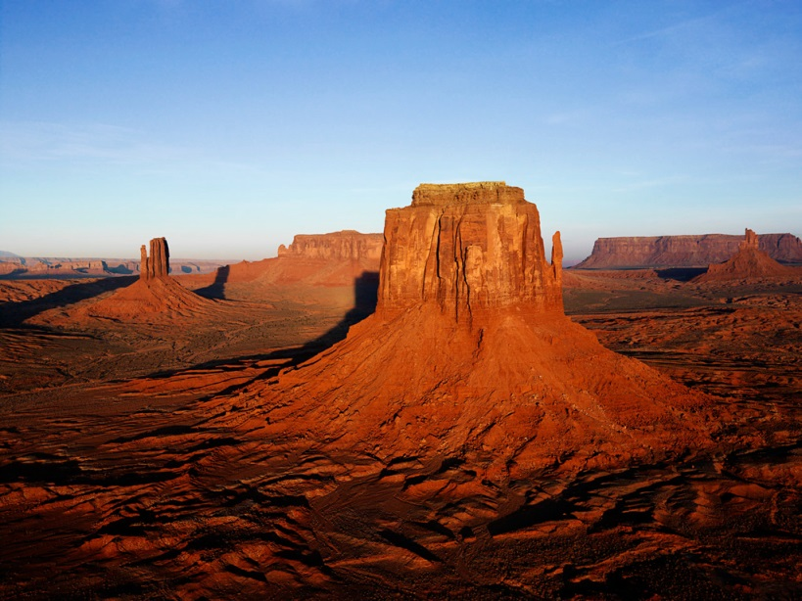

Figure 1 Random photo (Caption below, centred, Arial 10, bold)

If the paper includes equations, ensure equations are numbered, as shown in equation 1.

|  |  |  |
| --- | --- | --- |
|  | $$U_{\text{max}}=\sqrt{2}U_{\text{rms}}$$ | (1) |

All pages after title page must start from this line, i.e. 1” (2, 7 cm) margin from the top (Arial, size 12, single line spacing, justified). Text to remain as a single column. Pages will be automatically numbered.

The maximum length of a submitted paper is 10 pages (excluding the bibliography, i.e. Bibliography may start on page 11).

Paper Cont’d

—

—

—

—

—

—

—

—

—

—

—

—

—

—

—

End of text (This must not go beyond Page 10)

**BIBLIOGRAPHY**

Type the bibliography at the end of your text, according to this presentation (see sample references below). Font to be used is always Arial, size 12.

[1] Working Group SC 22-12 CIGRE. “The thermal behaviour of overhead conductors Section 1 and 2 Mathematical model for evaluation of conductor temperature in the steady state and the application thereof” (Electra number 144 October 1992 pages 107-125)

[2] T. Seppa “Fried Wire?” (Public Utilities Fortnightly, December 2003, pages 39-41)

[3] Prospectiva del Sector Eléctrico 2002-2011. (Secretaría de Energía. Mexico, 2002).

[4] Resolución sobre las Modificaciones a la Metodología para la Determinación de los Cargos por Servicio de Transmisión de Energía Eléctrica. (Diario Oficial de la Federación. Jueves 23 de Diciembre de 1999).